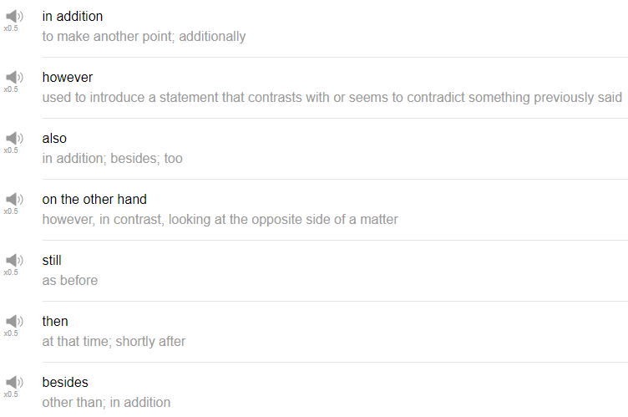

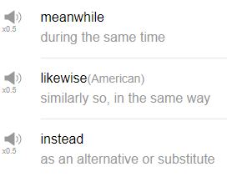

|  |
| --- |
| Whenever I'm ready, alright! Hi, everybody! Welcome back to Top Words, My name is Alisha. And today we're going to be talking about ten words for connecting thoughts, these are ten words that you can use to transition between ideas. Very useful in both speech and in writing. Let's go! |
| 1. Also |
| Also, also is a word that you can use to add information, “I went to the store this morning, also I went and got coffee” that's true. |
| 2. However |
| However, however is used to contrast or to contrast depending on your pronunciation to differentiate, to show a difference between two pieces of information, a good pattern would be A however B. So for example, “I love tonkatsu ramen however it is very high in calories so I don't eat it often” also true. |
| 3. On the other hand |
| On the other hand, on the other hand is, I feel used more commonly in speech than it is in writing. Again, it's used to present like two sides to a story or two sides to some information. So for example, “I'm thinking about visiting Taiwan sometime this year, but on the other hand, I'm also thinking about visiting Thailand.” |
| 4. Still |
| So it might be common to use still with the word like “but” or word like “even though”, so you're saying even though there's some other factor, like, “I'm really really tired this week” or “even though I have a lot of homework to do, I still want to go out with my friends” or “I still want to see a movie this weekend.” So there's this other, there's this thing that's maybe mix this other action difficult to do or tough to do or whatever, but even though there's this, you still have this over here. So maybe the two are kind of used as a pair. “I still want to go out later even though I'm tired.” |
| 5. Then |
| Then, yes a very useful word. We use then when telling stories a lot. So for example, if I could tell a story about my morning today “when I got up I brush my teeth, and then I cooked breakfast, then I did a little bit of work ,then I took a shower, then I did some cooking”, bla bla bla. |
| You'll often hear “and then” as well; and then I, and then we, and then you, and so on. So then it is really really useful for sequence, so a useful word, I think. |
| 6. Besides |
| Besides, so it's commonly used in a pattern like besides that, meaning other than something else. “I went out with my friends this weekend, but besides that, I didn't really do much.” |
| So another way to say that sentence is “I went out with my friends this weekend, but other than that, other than that activity, I didn't do very much.” Ok. |
| 7. Meanwhile |
| Meanwhile or you might hear the similar expression “in the meantime.” It means while you're doing action A, at the same time maybe somewhere else action B is happening. This is used while telling stories a lot. |
| So for example, “I was working at my office all week last week, meanwhile my co-workers across town were having a party without me.” So these two things are happening at the same time, but maybe separate from one another. Meanwhile. |
| 8. Likewise |
| Ok, likewise I don't really use this word personally myself at all, it's often used after an introduction similar to the “pleasure is all mine” in a formal situation. So maybe somebody says you know “Hey! it was really great to see you last weekend. Thanks very much for coming to my barbecue.” You can say “yeah, likewise, it was really good to see you and your family.” So likewise means I have the same feeling, or I have the same idea. It's kind of a friendly phrase but personally I don't really use that to transition between thoughts, I would just use “and,” I suppose, but that's how I would use it. |
| 9. Instead |
| Instead so so instead it's used like instead of I want to A instead of B can be used to express your plans or what you want to do “I want to have Chinese food instead of Italian food tonight.” So you're presenting two alternatives essentially. So instead of means “in place of” or “as a substitute for”. So “I should have drank a lot of water this morning but instead I drank a lot of coffee.” That's true. |
| “I wanted to have dinner with my friends this weekend. Instead, I had dinner at home” |
| 10. In addition |
| In addition, this is a really good word for more formal situations. I like to use in addition in writing, I don't really use in addition in speaking unless I'm trying to be very formal for some reason. Similar to additionally as well. So you make point A and point B, and then when you want to make one more point that's related to point A and point B, you can say, in addition, point C. So you're like building an argument, and in addition can be used to kind of finish that argument off a little bit. |
| “Our new marketing plan worked really well last month, we noticed increased sales in product A; in addition, we've gained a lot of new customers.” Something like that. So just, you’re quickly presenting a series of ideas that are related to one another, you can use in addition to finish it off. |
| All right, so that's the end of ten words for connecting thoughts. I hope you get to use a lot of these; try to mix it up, it's good to use a variety of different words. Thanks very much for watching this episode, and we will see you again next time for more fun stuff. Bye! |
| Whenever I'm ready. |